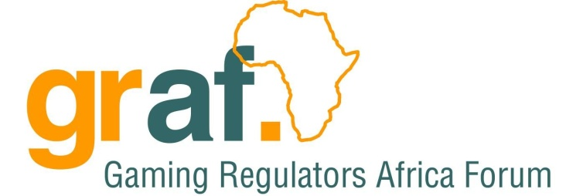

CIRCULAR TO UPDATE ALL GRAF MEMBER STATES - 2013-03-25

FROM SECRETARIAT ON BEHALF OF THE GAMING REGULATORS AFRICA FORUM Chairperson: Mr Mdundo

Dear GRAF member states

You are cordially invited to the first Technical meeting of GRAF member states; CEO,

The meeting will be chaired by Mr Mdundo – the chairperson of GRAF and chairperson of the Tanzania Gambling Board.

Attached is the circular relating to the meeting as well as the proposed agenda for the day.

Included are also draft minutes from the meeting of the 27 May 2012, held at the 9th GRAF conference hosted by Tanzania Gambling Board.

Regards

NGB Secretariat

On behalf of the Chairperson of GRAF: Mr Mdundo

Contact details:

NGB: 420 Witch-hazel Avenue

Eco Glades 2, Block C

Centurion, 0144

South Africa

Telephone: 0100033475

International calls: +2700033475

Details of the meeting:

Day: 28 March 2013

Time: 11am

Venue: Maputo (TBC)

Telephone: +255 222124701

